Competency Demonstration

CIS 242 Final Project:



Pages

This project is a website with 8 pages of which 7 include some sort of dynamic content.

* about.html
* browse.html
* checkout.html
* contact.html
* index.html
* order.html
* summary.html
* thanks.html

Description

The Corner Store is a site themed around selling strange items that share a theme of evoking a sense of unease. It’s a little shop of horrors, online! There are 12 items available for order each of which has an option for shipping in a box or crate (which is a 10 dollar add-on before tax). Once a user has added the items they want to their cart, in the quantities that they desire (limited by available quantity), after passing an order screen where they can tweak their order in detail, they can proceed to a checkout form where they may submit some personal information necessary for shipping. Finally, once they fill out the form with valid information, they are taken to a summary of their order which includes estimated shipping times, a live countdown, the items purchased, and the total including tax.

Visitation Order

The majority of the pages can be visited in any order, but to ideally, the user must have added an item to their cart in either index.html or browse.html and filled out the form in checkout.html before visiting summary.html (there are checks to ensure that this is the case this if the user is not able to do this unless they navigate to summary.html directly by url). In that event, the summary page will display “nothing to see here!” instead of an order summary.

Index.html

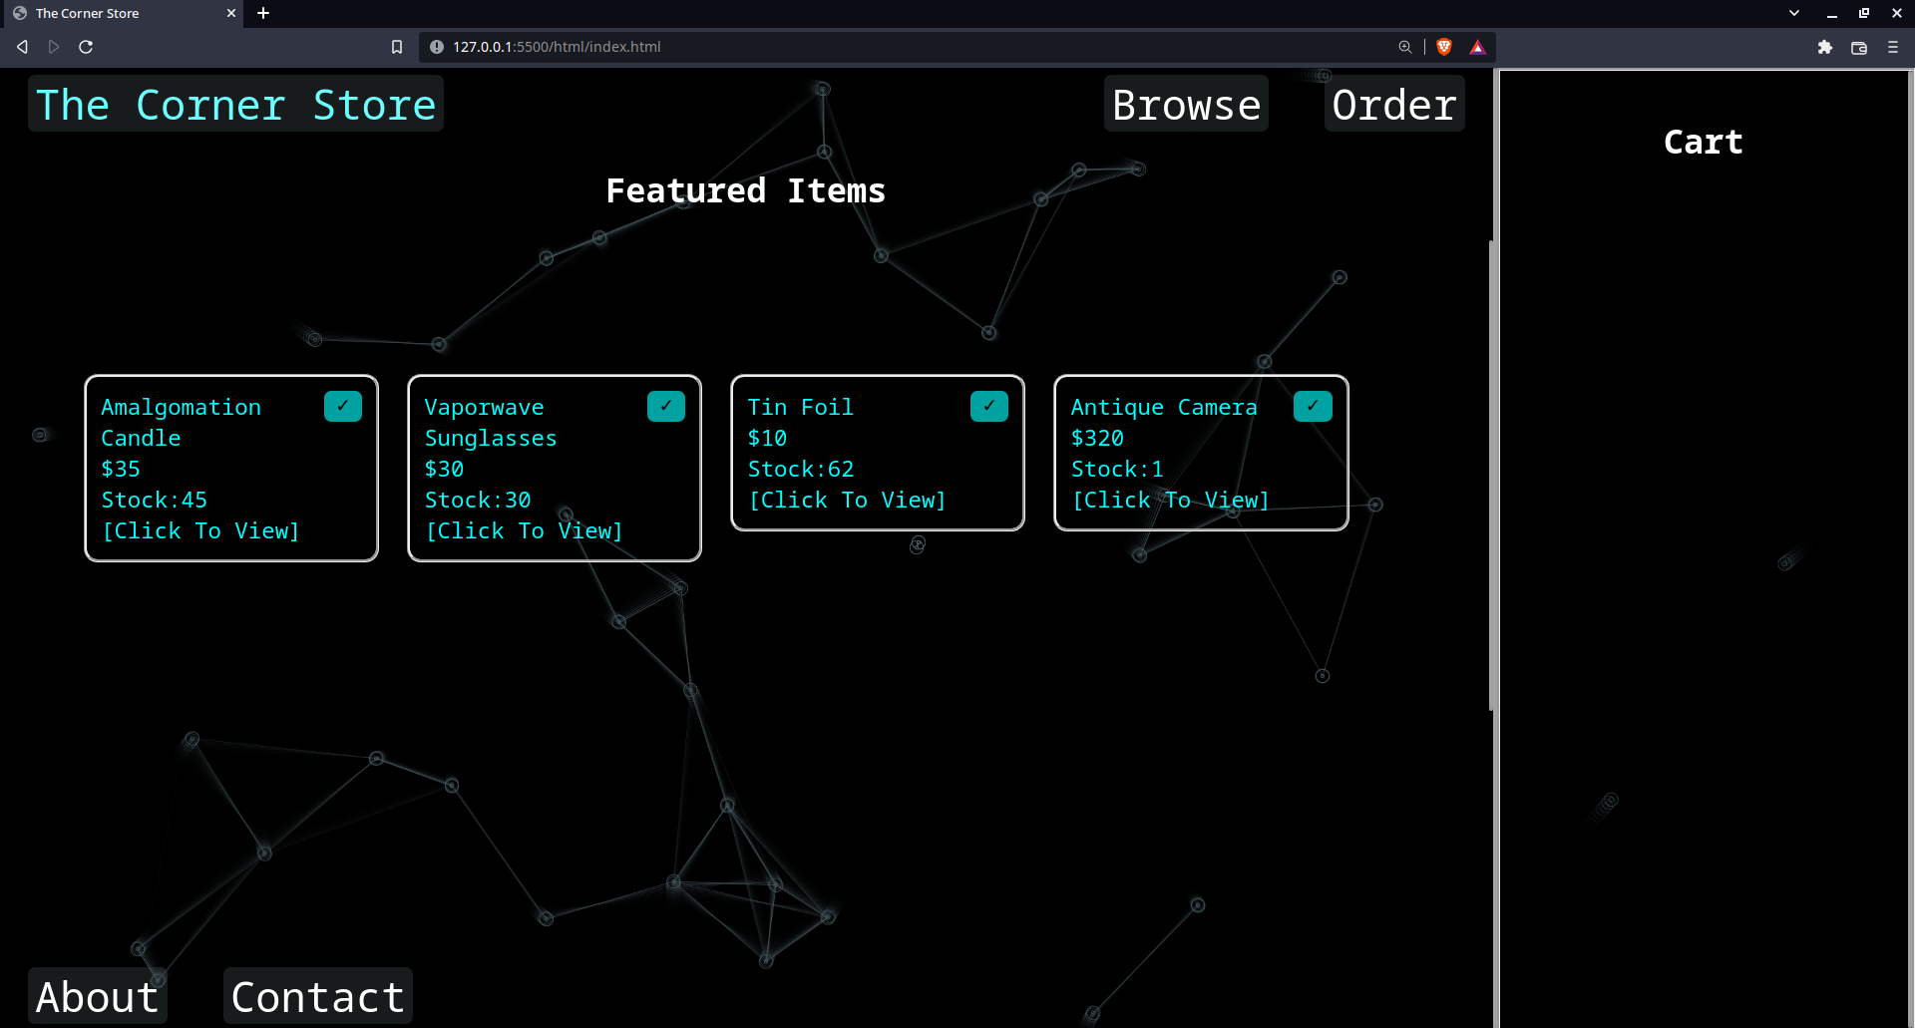

The landing page jumps straight into things.

From here you see featured items that you can instantly add to your cart or view a preview for.

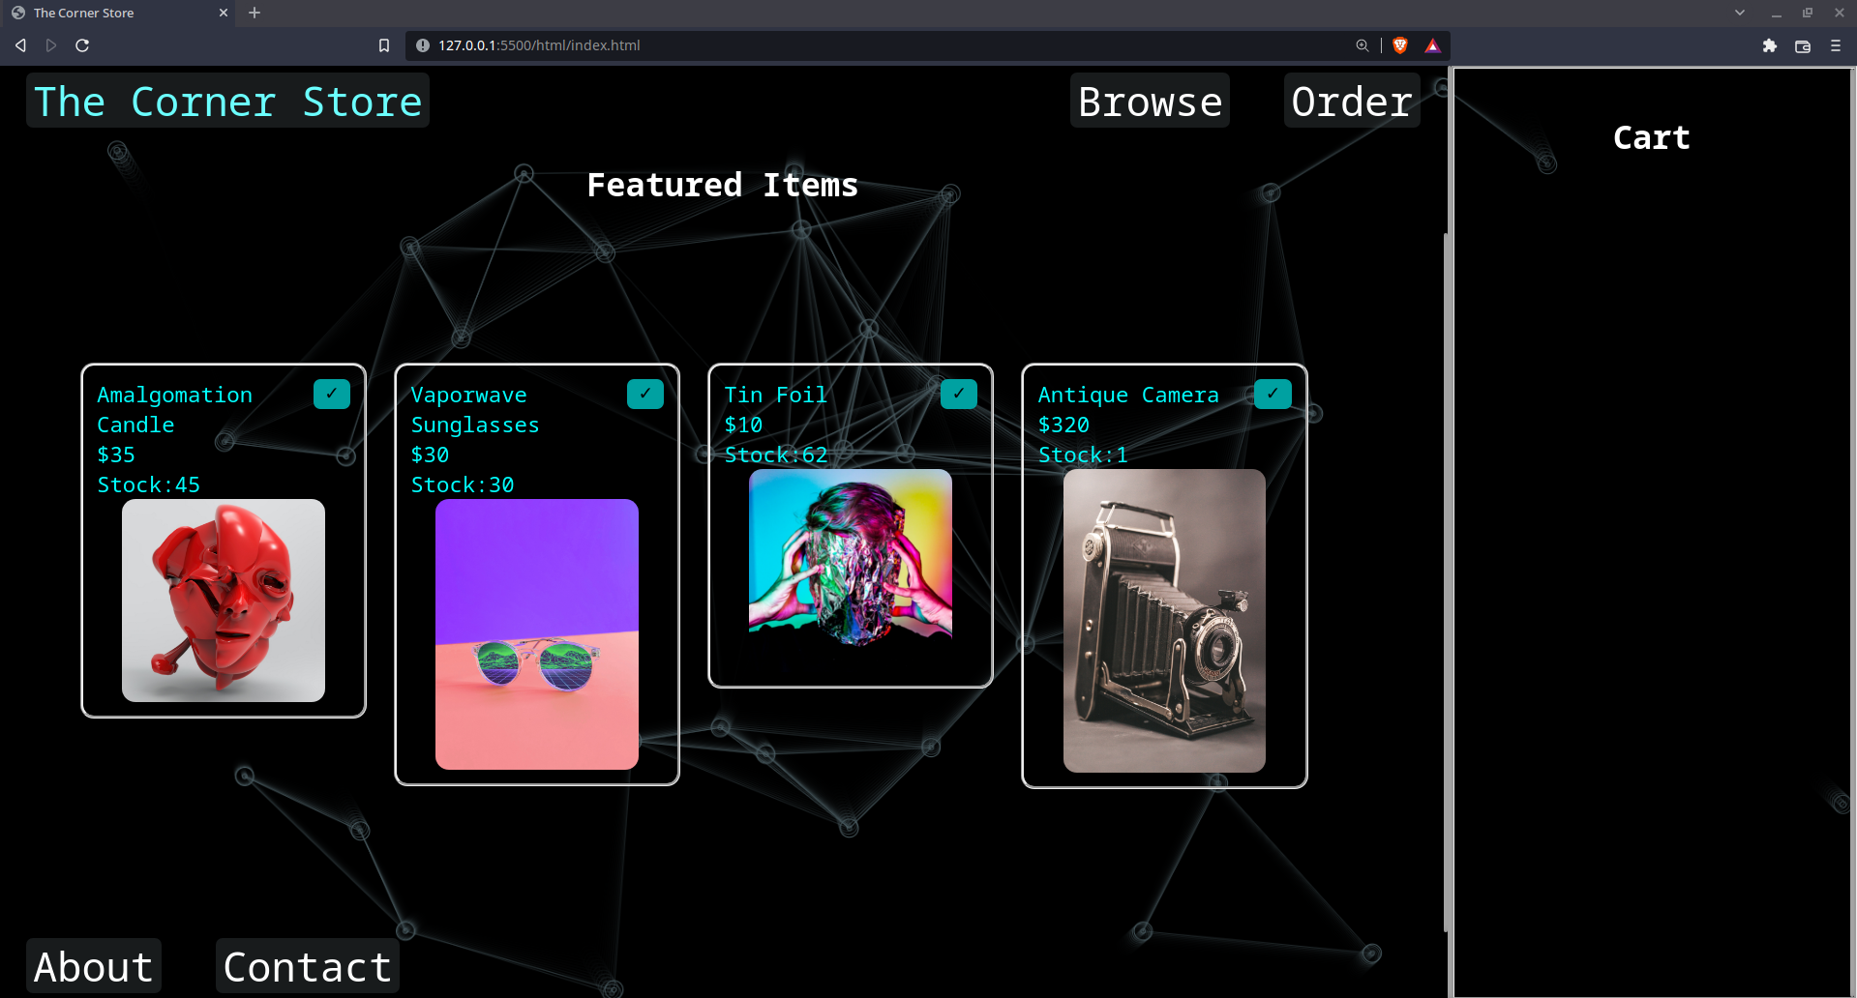

By clicking on an item, you can see an image preview of the product.

Browse.html

Here you can see all of the products available for order.

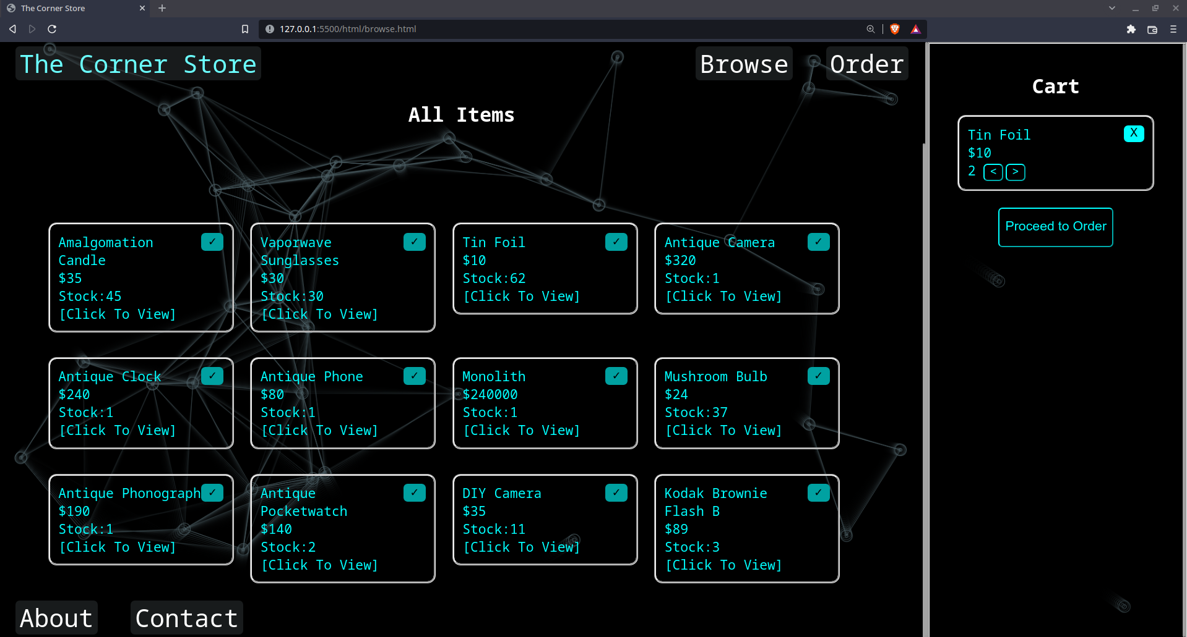

Clicking the check mark on an item will add it to the cart, clicking it multiple times will add more quantity (if available).

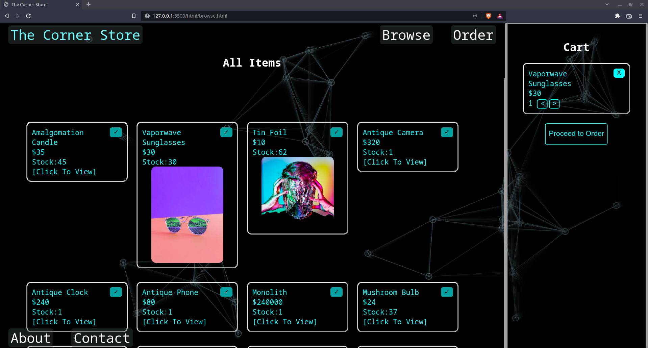

Clicking an item in the products area will still allow you to view a preview.

Objects in the cart cannot be previewed.

Order.html

The order page allows you to customize your order and proceed to checkout once it is to your liking.

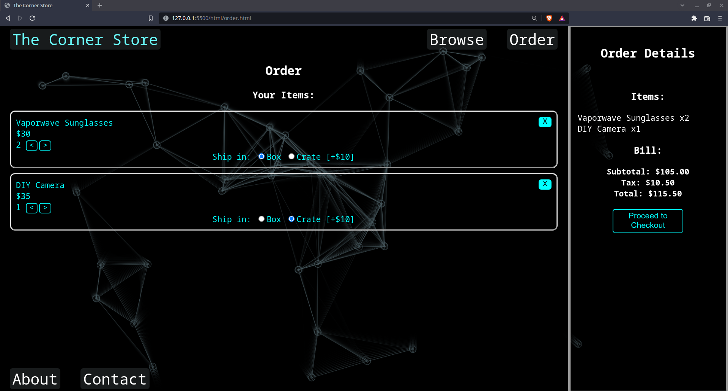

You can select if you want your items to ship to you in a box or in a crate and can see a live preview of your bill that updates as you change your order.

You can only proceed to checkout once you have at least one item in your cart.

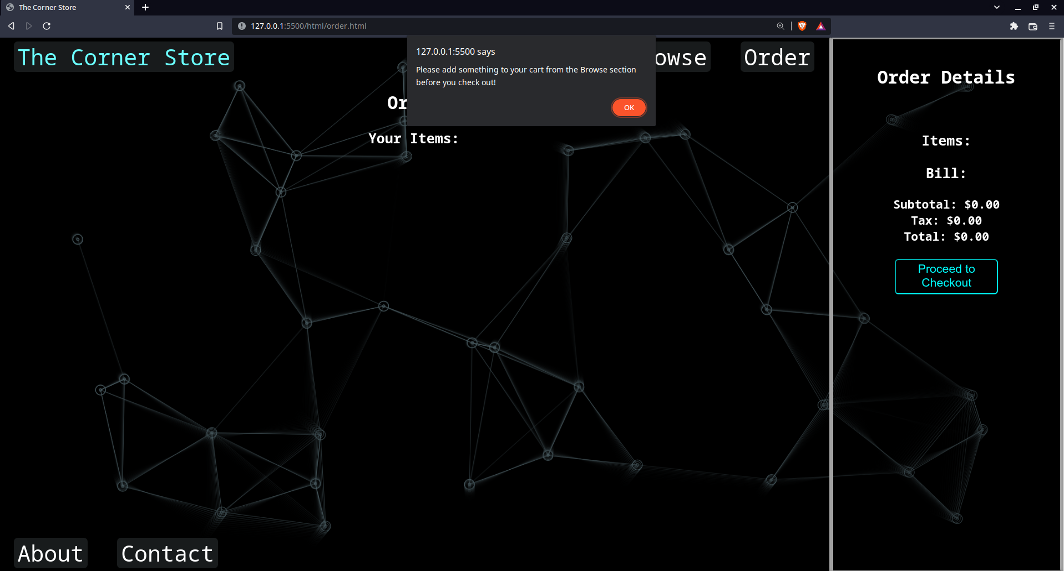

Checkout.html

From the checkout page you can fill out the information needed for item delivery.

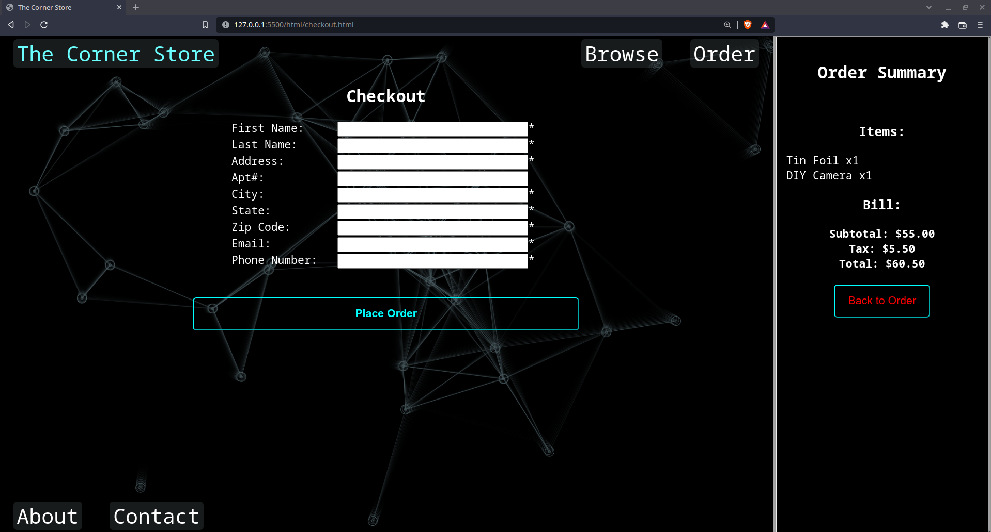

You cannot place your order unless all fields (except Apt#) contain a value, and the Zip code, Email, and Phone Number are all in a valid format.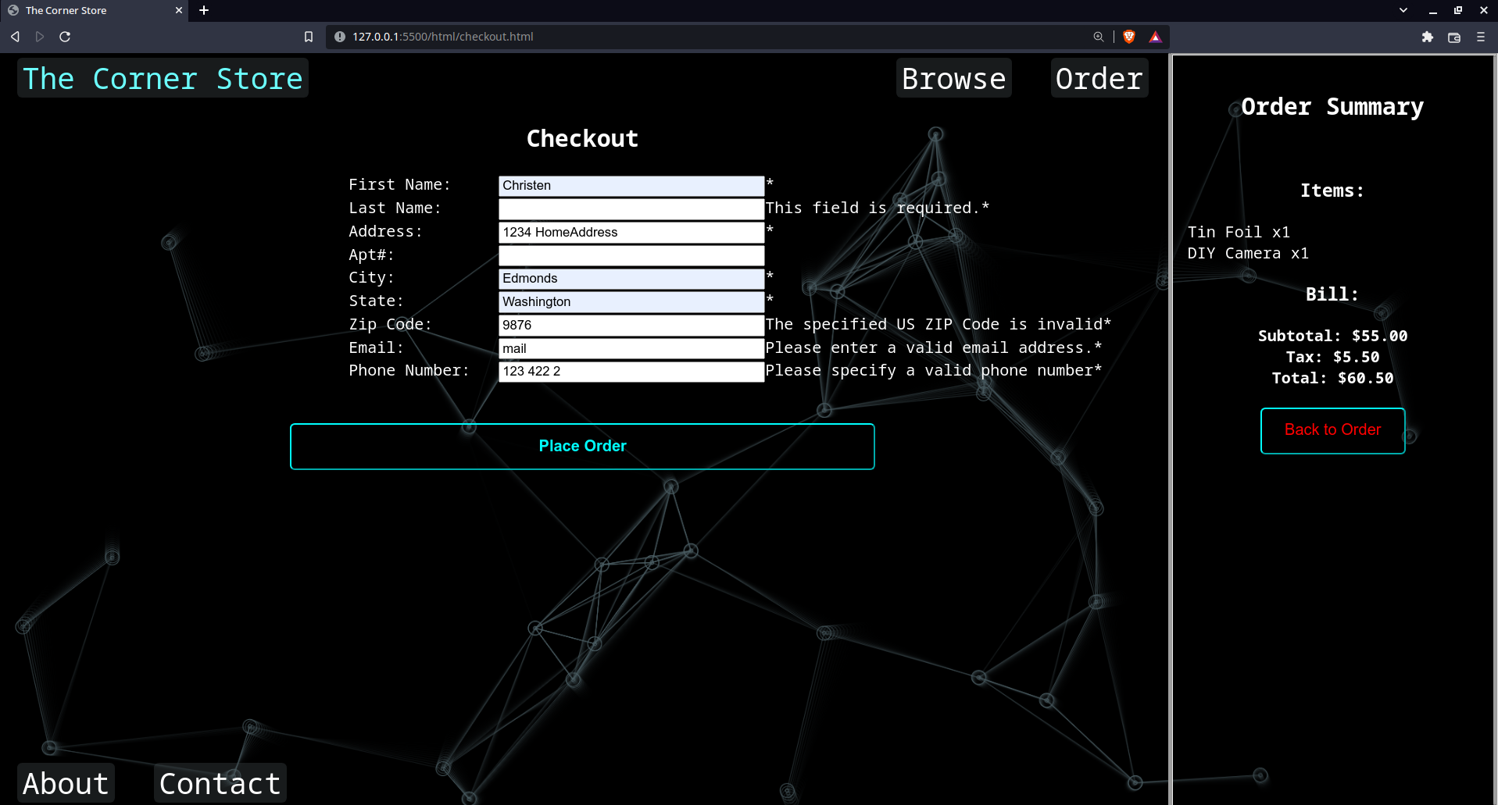

Summary.html

On the summary page, you can see a summary of the items that you have purchased.

You can also see delivery details, a real time countdown to the estimated arrival time, previews of the products you ordered, and their cumulative price.

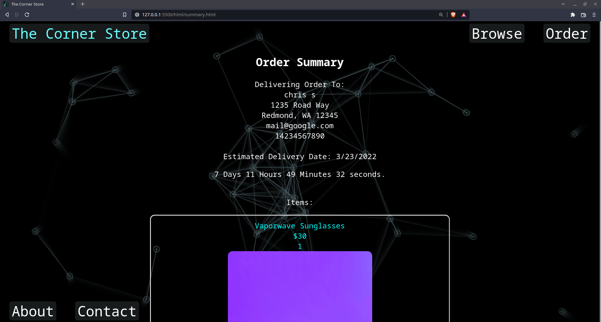

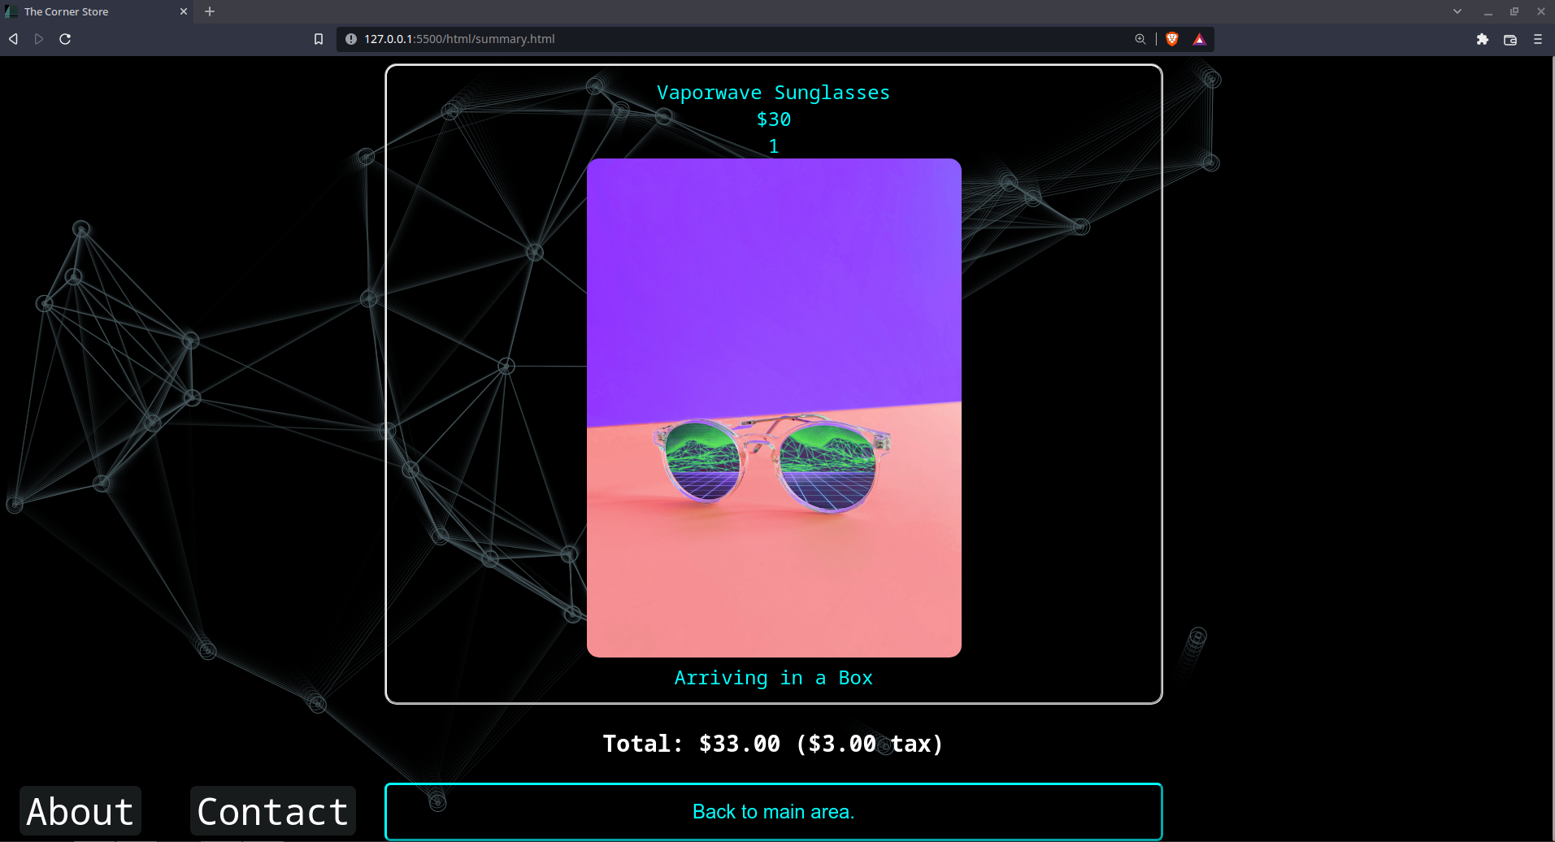

From this page, you can return to the main area to make additional purchases or close the site if you would like.

About.html

Displays a short, cryptic blurb about the site.

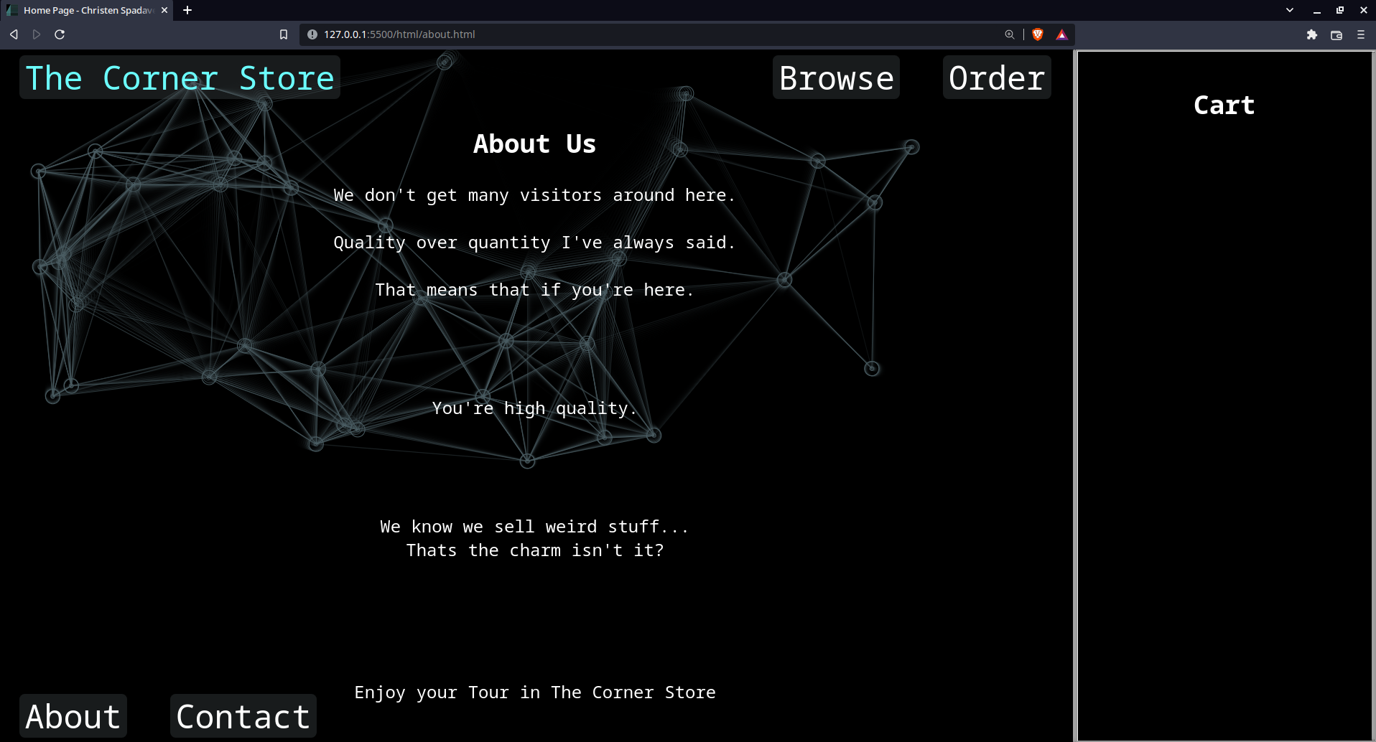

Contact.html

Displays a short form that allows you to get in touch with The Corner Store

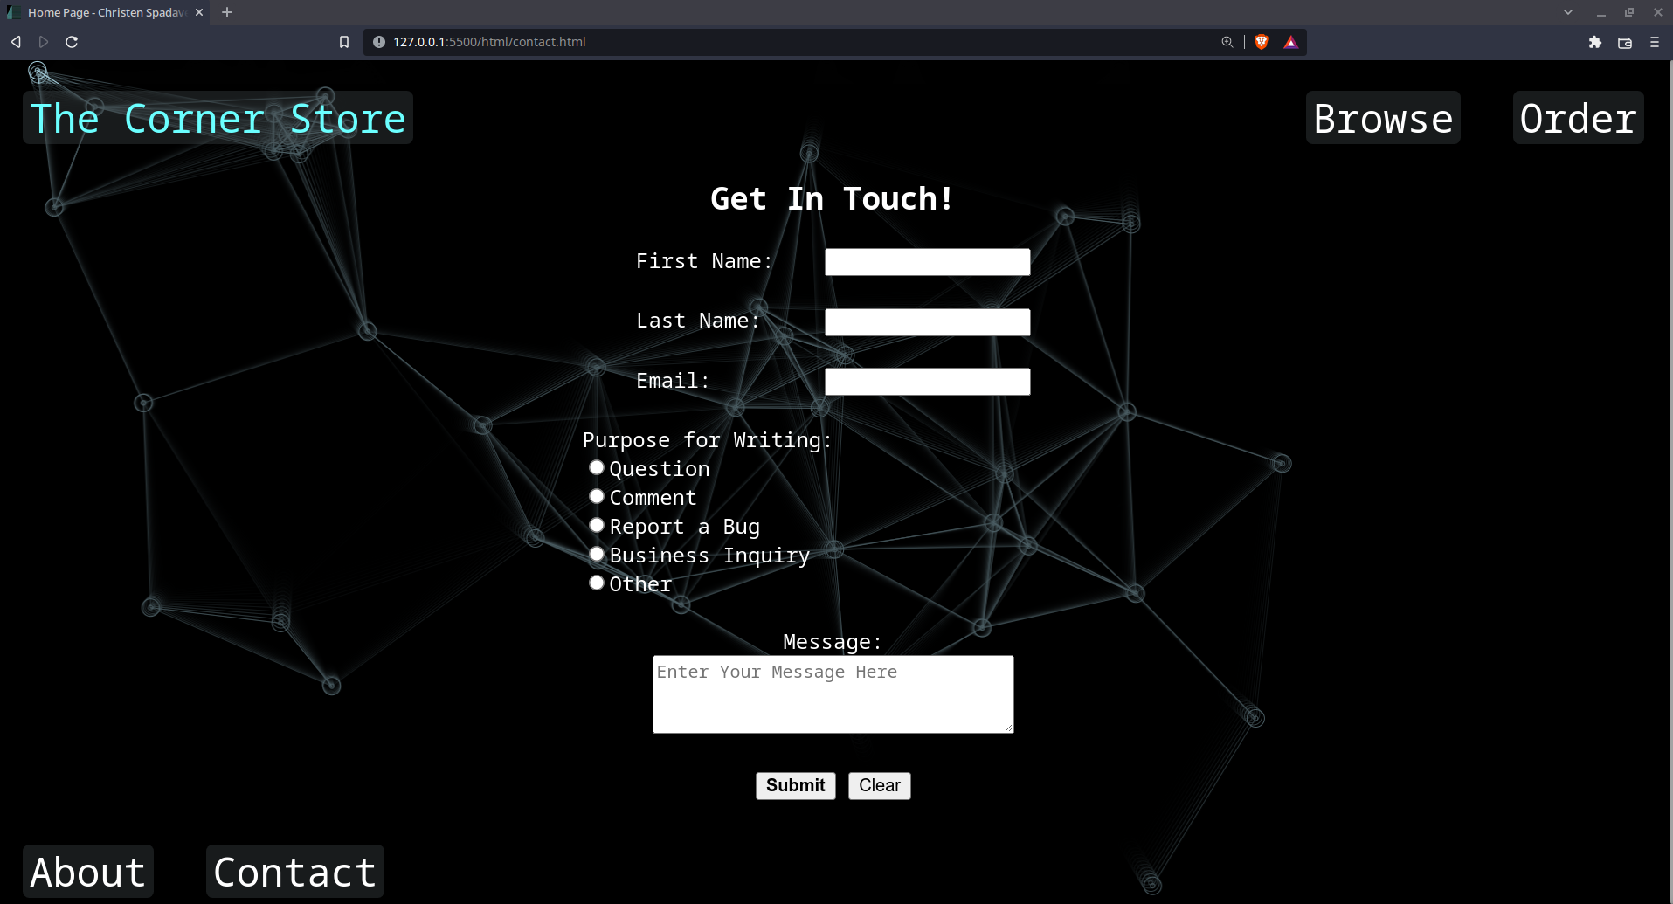

(All inputs are checked for having been filled out)

Thanks.html

You are redirected here after successfully filling out the form in contact.html.

